Erickson B2B Portal
Contents
Introduction & Accessing the B2B Portal 3
Bulk Downloading of Files/Folders 7

Introduction & Accessing the B2B Portal
Welcome to Erickson’s new B2B Portal. We have put together this user guide to help with the following processes:
Login to our Portal, Navigation within your company site and within Erickson’s B2B homepage.
You will receive a link via email, click your companies name and follow the instructions. Save a short cut on your desktop for future use. (Example of Link)
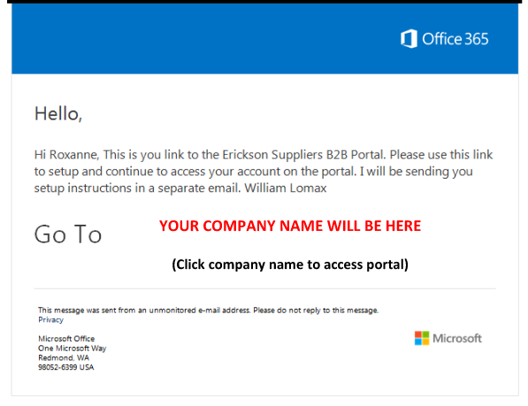

If you lose or do not have a link, using Internet Explorer you can also type in https://ericksonaircrane.sharepoint.com/sites/CustomerPortal (Note: the portal may not work properly if you use a browser other than Internet Explorer (i.e. Google Chrome, Firefox, etc.).

While at the Office 365 sign in page (Login page for the Erickson B2B portal), Select the “Organizational account”
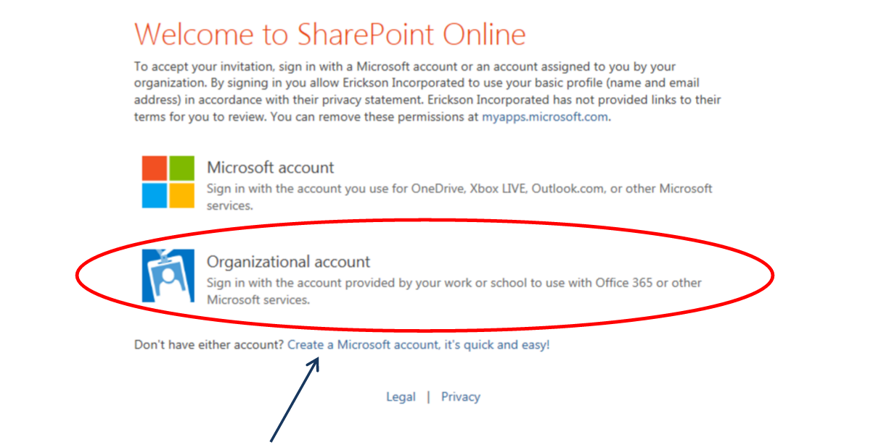
NOTE: If you DO NOT have a Microsoft or 365 account, you will need to create on by selecting “Create a Microsoft Account” and follow the instructions
The Microsoft account “Sign in” page appears, External Users then enter email (not visible to or controlled by Erickson) “This must be the email you supplied for accessing the B2B Portal”.
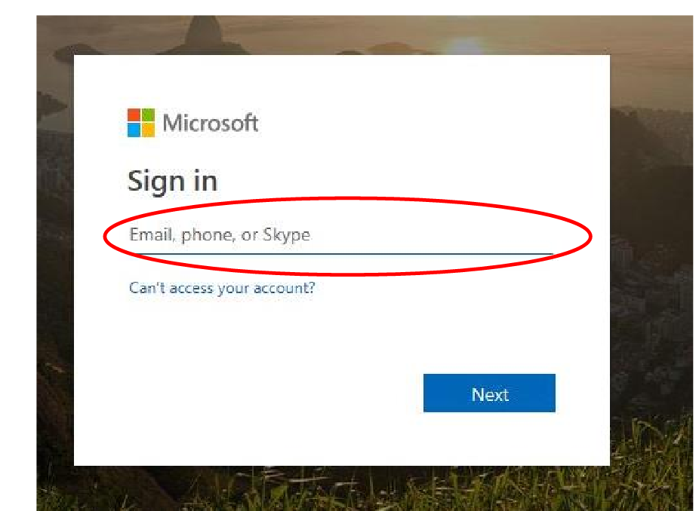

User will enter their password that is assigned to their email account.
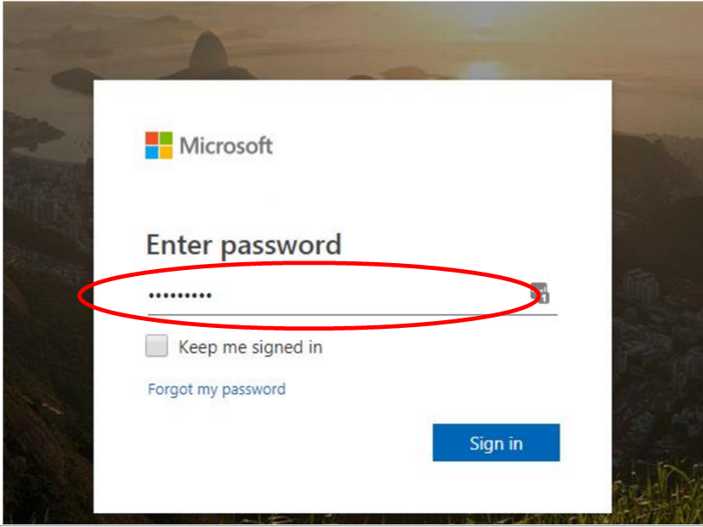

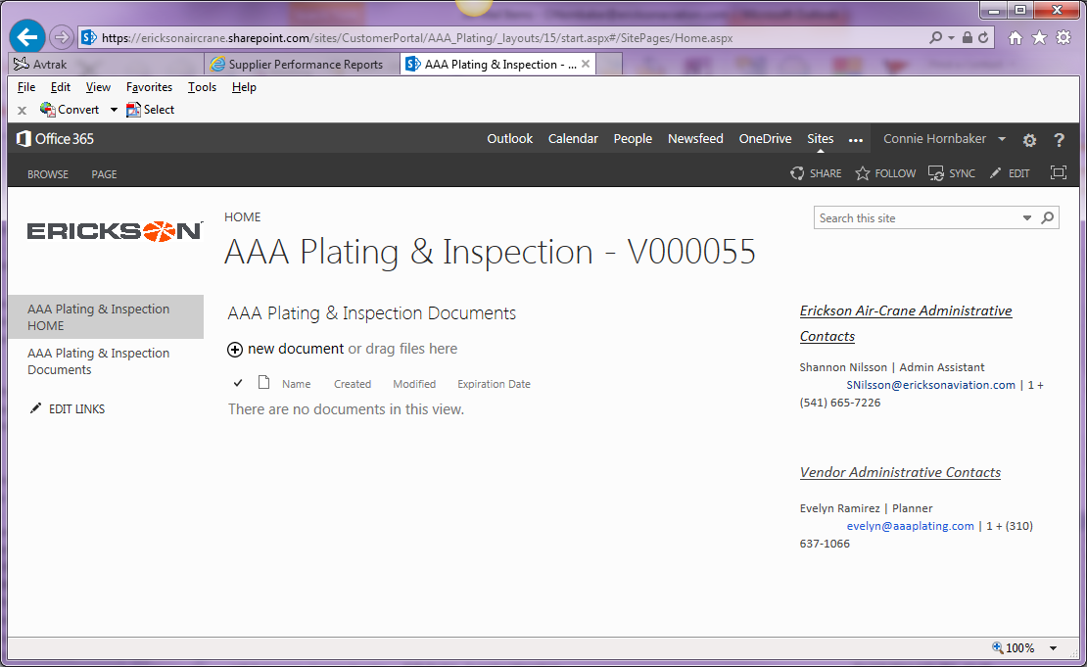
When you get into the portal, a page similar to the one below will be open with your company name Vendor number (Vxxxxxx). You will be in the Specified Supplier Home section.

Click on the Documents folder on the LH Sidebar for your company.
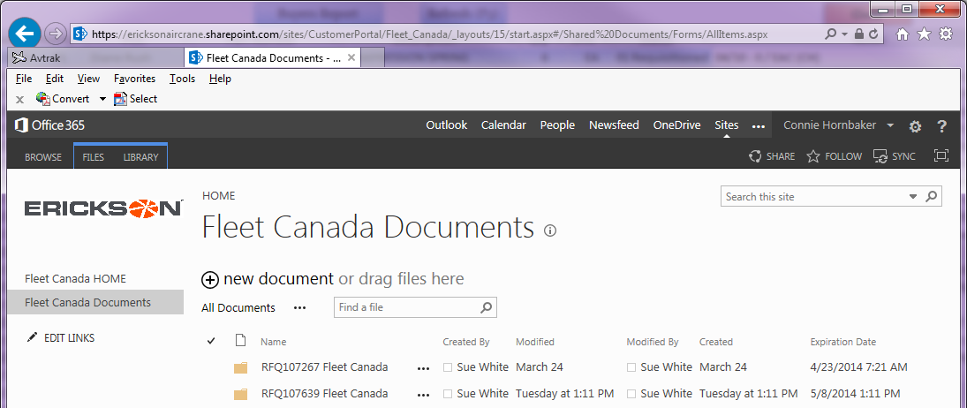
Click on the folder (icon), then drag to a folder on your local network/computer (Note: If you click on the name it will not work).
If you click on the HOME at the top of the page, this will take you to Erickson’s portion of the B2B Portal and will allow you to download common specifications, documents, etc.
The Erickson B2B “Landing Page” should appear similar to above, but with a link to the corresponding External User specific Site under the “Subsites” heading. Clicking on your company name here will take you back to your Company Specific page.
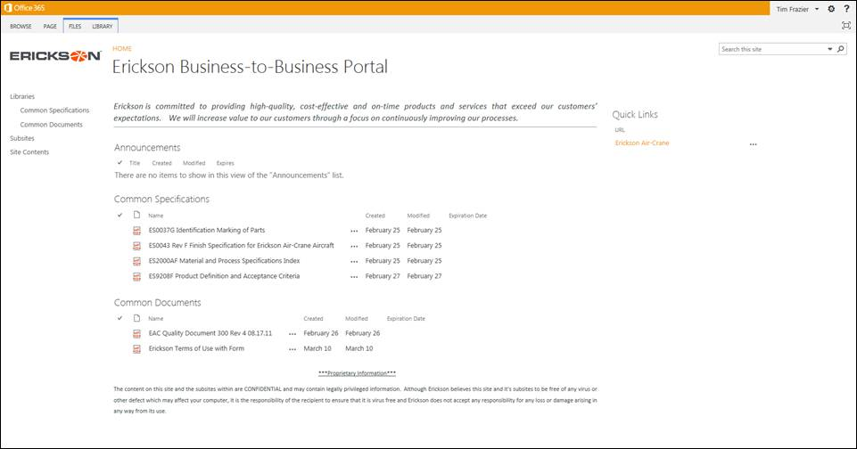
Please help us with our continuous improvement process and provide us with feedback, to improve this manual and the use of our Portal.
E-mail your feedback to: Purchasing Manager

Bulk Downloading of Files/Folders
Browse to your company “Document Library” as shown below:
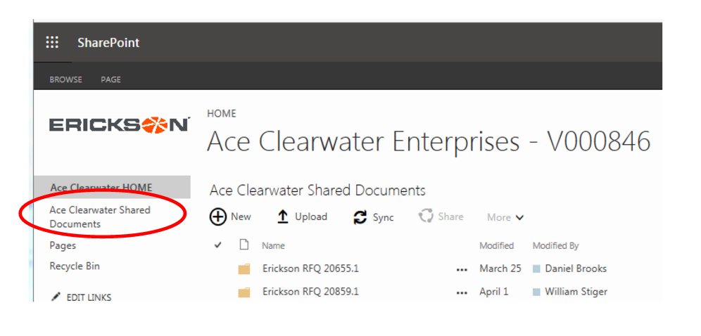
While in your company “Document Library”, go to the “Library” tab at the upper left, then select “Open with Explorer” as shown below:
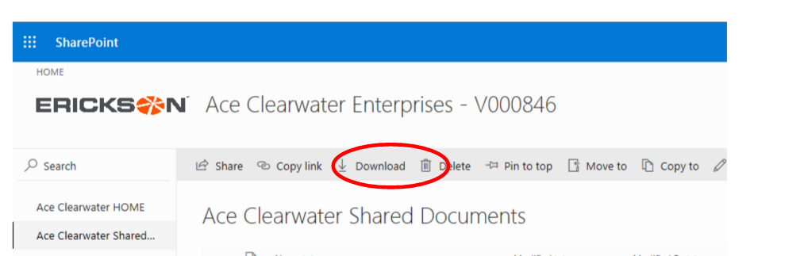
The screen may disappear for a couple of seconds then a box at the bottom will appear. Then select the drop down next to Save▼ select Save As.
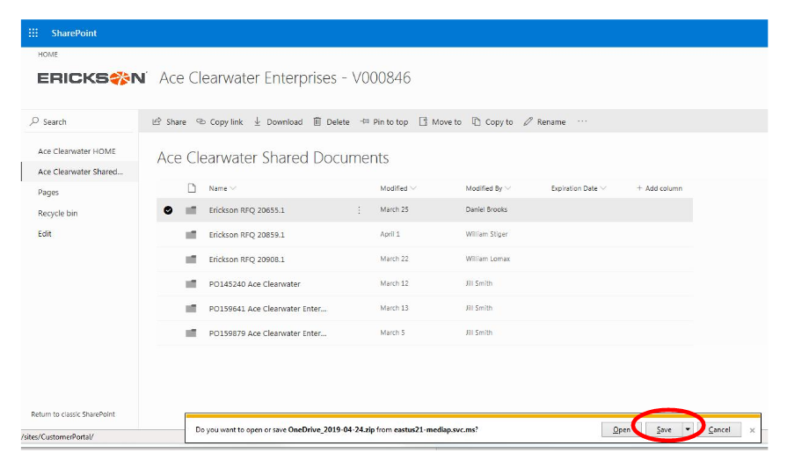

You can also open the folder and select the files you want to download and follow the same as the previous window.
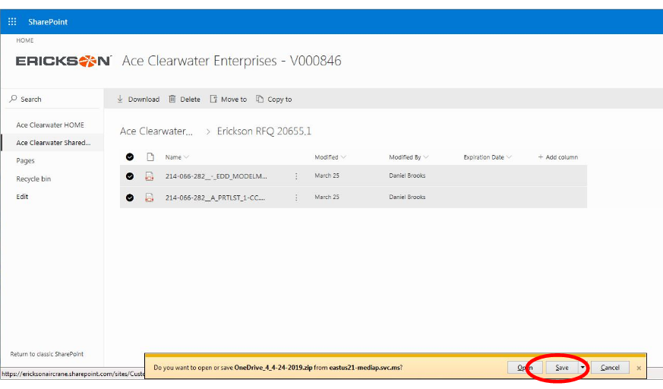
Browse to where you want to store the drawings and Create a New Folder and name it so you will remember. Open the folder and select Open. The folder or files will be saved in the New Folder as a .zip file.

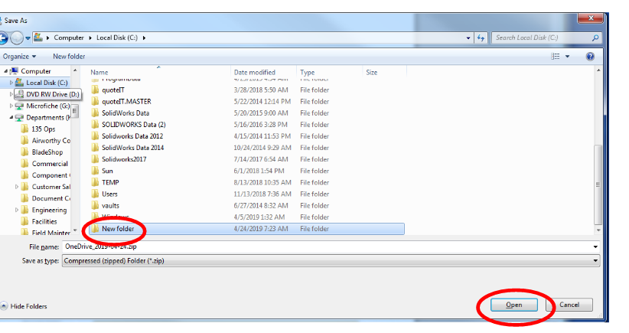

Right Click on the .zip folder and select Extract All
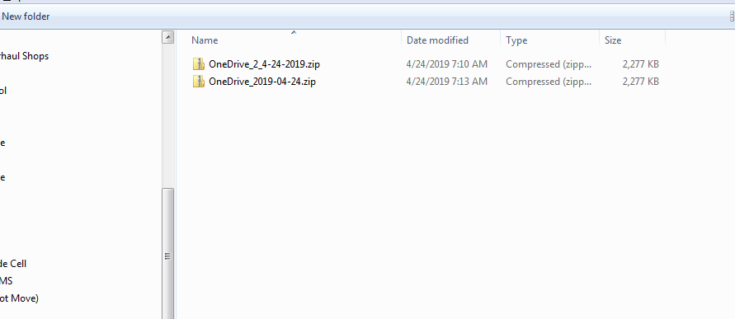

Then Select Extract. This will extract the files that have been Downloaded.
